緬甸旅遊須知

Myanmar Travel Guidelines
1、海關：外國旅客可攜帶美金入境緬甸，而美金超過2000元以上一般需要報關。攜帶貴重物品進入緬甸需要報關以便於日後順利出境。在緬甸境內購買的珠寶玉器、精緻佛像必須附有收款憑證，便於查驗出境。

1. Customs: Foreign visitors can bring U.S. dollars into Myanmar; however, cash must be reported if the amount is more than $2000. Valuable items are recommended to be reported when entering Myanmar, it will smooth the departure process when exiting the country. When purchasing Jade, jewelry and exquisite statues in Myanmar, you must get the receipt from vendors. This will help you ease and pass the inspection when leaving Myanmar.
2、天氣：緬甸全年平均溫度大約為攝氏26-36度。全年分為旱季和雨季。旱季為10月至來年4月。旱季是緬甸黃金旅遊季節，天氣晴朗，遊客需自備防曬霜、墨鏡、遮陽帽等物品；雨季為5月至9月初，仰光等緬甸南部地區雨水較多，建議遊客攜帶雨具。
2. Weather: Myanmar’s average temperature is about 26-36 degrees Celsius. The season is divided into dry and wet seasons throughout the year. Dry season is from October to April. Myanmar prime tourist season is during the dry season. The weather is sunny, visitors should bring sunscreen, sunglasses, hats and other items. Rainy season is from May to early September. Yangon and other southern regions has more rainy weather, visitors are advised to bring rain gears.
3、時差：緬甸比洛杉磯時間快13小時30分 (已加上日光節約時間)，如洛杉磯為早上8:00，則緬甸時間為晚上9:30。
3. Myanmar time zone is UTC +6:30. LA time zone is UTC -7:00 (Daylight Saving). Therefore, Myanmar time is 13:30 hours ahead of LA time. For example, as of 8am in LA, the Myanmar is 9:30pm.
4、治安：緬甸是全民信教的佛教國家，治安情況較好，犯罪率底。除了緬甸、泰國、老撾交界的金三角地區以外，遊客可放心旅遊。但是小心謹慎仍然是一個成熟旅遊者必備的素質，錢財等最好不示人和外露，特別是喜歡攜帶大量現金的中國人更應自律。切記晚上別到偏僻人少的地方遊蕩，以免招致禍端。

4. Public Safety: Myanmar is a Buddhist country, the public security is safe. The crime rate is low. Except the Golden Triangle area, the border of junction of Myanmar, Thailand and Laos, visitors can travel safely. However, caution is still an essential quality for every mature tourist. Money should not be exposed. People, especially Chinese who like to carry large amounts of cash, should be very careful. Do not hang around a remote place in the evening to avoid trouble.
5、衣著：因為緬甸全年氣溫較高，所以遊客著裝以輕便、涼爽、舒適的夏季衣物為主。遊客最好自備牙膏、牙刷、拖鞋及洗浴用品。女士可著裙裝，但是不能著短褲。前往密支那、茵萊湖的遊客最好攜帶一件抓絨戶外衣服，因外那些地方是緬甸高原，早晚溫差大。
5. Clothing: Myanmar temperatures are relatively high throughout the year. Most visitors dress in lightweight, cool and comfortable summer clothes. It is recommended to bring your own toothpaste, toothbrushes, slippers and toiletries. Ladies can wear dresses, but not the shorts. Visitors going to Myitkyina or Inle Lake are recommended to bring outdoor warm clothes. Because those places are Myanmar plateau, morning and evening temperature varies.

6、稅項：遊客在仰光、曼德勒等國際機場離境時，需購買離境稅，每人10美金，就在機場購買。而乘坐緬甸國內航班則不需要購買機場稅。

6. Tax: Tourists are required to pay departure tax when departing in Yangon, Mandalay or other international airport. $10 per person. However, this tax is not required for domestic flight in Myanmar.
7、語言：緬甸語是官方語言，英語為通用語言，但是緬甸的英語教學品質不敢恭維。仰光、曼德勒等城市有很多華人，可用漢語溝通。但是緬甸的計程車司機的英語很蹩腳，需要耐心慢語方能簡單溝通。當你碰上華人模樣的賓館服務人員或司機時，講英語前最好先用漢語試試，免得大家都很費勁。

7, Language: Burmese is the official language. English is the universal language. However, the quality of English in Myanmar is poor. Yangon, Mandalay and other cities have a lot of Chinese, Chinese communication is available. But Myanmar taxi drivers' English is very poor, patience is needed to accomplish a simple communication. When you run into a look-like Chinese hotel staff or driver, trying to communicate in Chinese before speaking English; it may save you a lot of trouble.
8、藥物：緬甸醫療比較落後，遊客請自備一些防治中暑的藥以及止瀉藥、創可貼、感冒藥等。

8, Medicine: Myanmar is relatively behind in medical advancement, visitors please bring band-aid and some medicine for heat stroke, diarrhea, cold…etc.
9、電壓：緬甸的電壓是220-230V，同中國一樣，但插座僅僅是一些酒店與國內一致無須轉換，大部分酒店均需轉換器，緬甸的插座普遍分為3種，所以一定要自備旅行裝萬能插頭轉換器。

9. Voltage: Voltage in Myanmar is 220-230V, same as China, but the socket varies from place to place. Converters are required in most of the hotels. It can be generally divided into three kinds of sockets. So be sure to bring your own Travel Pack universal plug adapter.
1.三項扁頭，一般高級酒店使用(13 A plugs, usually used in Luxury hotels)

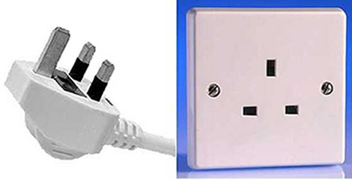

2.兩項圓頭，德標（歐標）普通或高級酒店常用 (CEE 7 standards or Euro plug, used in most standard or Luxury hotels)

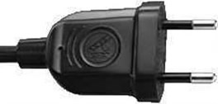

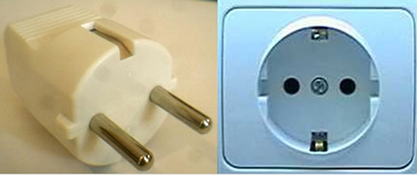

3.三項圓頭（南非標） (Thai 3 pin plug)

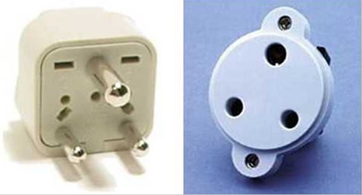

10、通訊：緬甸的通訊落後，手機使用很少。截止到2011年元月，中國手機還不能在緬甸漫遊，當地的手機卡也只有CDMA能裝在中國同制式手機上使用，但是CDMA的卡很難買到，所以中國遊客帶的手機只能當手錶使用了。在緬甸的酒店和網吧裡可以打國際長途，但是資費很貴，除非有必要，建議大家把千言萬語留到回國後在講。

10. Communication: Myanmar mobile technology is very behind, mobile phone usage is very little. As of January 2011, China Mobile cannot roam in Myanmar. Only phone card with CDMA standard can be installed on Chinese standard mobile phone, but it is very difficult to buy CDMA card in Myanmar. So Chinese tourists use mobile phones as watches. In Myanmar, you can make international calls in hotels and cafes, but charges are expensive. Unless it is necessary, we recommend that you save your thousand words until you return back home.
11、貨幣：緬甸貨幣單位為KYAT，中文發音是：“基-耶”。人民幣在緬甸境內不能兌換和使用。外國遊客在緬甸基本使用美金，現今的匯率是1 USD：970 KYAT左右。在緬甸的酒店都能用美元兌換緬幣，在市區餐廳也能兌換。仰光等南部城市的匯率比曼德勒、蒲甘等比划算，最差的是茵萊湖等純旅遊區。而最划算的是在仰光的昂山市場。
請記住：緬甸人只用新版的美元，舊版的一般會被拒絕或者在匯率上損失不少。看著很皺皺巴巴的破舊美元在緬甸是廢紙，沒人跟你換的。
11. Currency: Myanmar monetary unit is KYAT, The RMB is not exchangeable nor use in Myanmar. In Myanmar, foreign tourists use U.S. dollar to trade. The current exchange rate is 1 USD to 970 KYAT. Hotels in Myanmar and many restaurants offers currency exchange. However, different places may offer different exchange rate. For example, southern cities of Myanmar have better exchange rates than Mandalay and Bagan. Places like Inle Lake or other Tourist Attractions have the worst exchange rate.
Note: Burmese people only use the new version of dollars bill. Old bills will generally be rejected or lost a lot on the exchange rate. No one would trade in wrinkled old dollar in Myanmar.

12、購物：緬甸特色的紀念品以手工藝漆器、紅藍寶石、玉器、古玩和海產品為主。如果您要經過仰光，去昂山市場自由購物是最好的選擇。昂山市場商品繁多，價格合理，可以大刀闊斧的砍價。曼德勒的緬甸提線木偶和柚木工藝品很有名；蒲甘的沙畫具有濃厚的小乘佛教韻味；而在茵萊湖，用蓮藕絲織成的衣物和圍巾等深受遊客喜愛。

12. Shopping: Burmese featuring souvenirs are handicraft lacquer ware, ruby, sapphires, jade, antiques and seafood. If you are passing through Yangon, Bog yoke Market is the best option to go shopping. Bog yoke Market have variety of commodity and reasonable prices. And prices can be bargain. In Mandalay, teak crafts and Muppets and famous. In Bagan, sand painting has a strong distinctive feature of Theravada Buddhism. In Inle Lake, lotus root silk scarves and clothing are loved by tourists.
13、禮儀：緬甸是佛教國家，也是對中國遊客很友好的國家。緬甸民風樸素，旅客須遵守佛教禮儀，進入所有的寺廟都需要脫鞋及穿著整潔之服飾。女士必須穿長褲長裙進入寺廟。特別提示：在任何場合，避免談及對佛教不敬之言論，絕不談及對緬甸軍政府有任何不敬的言論，也不要參與到西方遊客對緬甸政府的討論話題中。

13. Etiquette: Myanmar is a Buddhist country, and it is very friendly to Chinese tourists. Myanmar simple folk, tourists are subject to Buddhist rituals. People entering temples are required to take off shoes and to wear proper clothing. Ladies must wear long dress or long pants to enter the temple. Special Note: In any places, do not disrespect Buddhism in any way. And, do not have disrespect conversation about the government of Myanmar. And, avoiding discussion in topic of government of Myanmar with western tourist.

緬甸依舊是個半開放的國家，除了中部的仰光，曼德勒，浦甘，茵萊湖和TAUNGGYI地區以外，不跟團的外國旅遊者要去其它地方旅行必須先申請旅行許可證（TRAVEL PERMIT），否則會被視作違法。
Myanmar is still a semi-open country. In exception of Yangon, Mandalay, Bagan, Inle Lake and Taunggyi region, foreign tourists without any travel agency traveling elsewhere in Myanmar is required to present a travel permit; otherwise, it will be deemed illegal.

